11.6.1 Packet Tracer – Configuring Basic EIGRP with IPv4
Vlan Table
Switch | VLAN Number | VLAN Name | Port Membership | Network
SW-1 | 10 | Admin | F0/1, F0/2 | 192.168.10.0/24
 | 20 | Sales | F0/10 | 192.168.20.0/24
 | 99 | Management | F0/24 | 192.168.99.0/24
 | 100 | Native | G0/1, G0/2 | None
 | 999 | BlackHole | All unused | None
SW-2 | 10 | Admin | F0/1, F0/22 | 192.168.10.0/24
 | 20 | Sales | F0/10 | 192.168.20.0/24
 | 99 | Management | F0/24 | 192.168.99.0/24
 | 100 | Native | None | None
 | 999 | BlackHole | All unused | None

Objectives
- Part 1: Create a Secure Trunk
- Part 2: Secure Unused Switch Ports
- Part 3: Implement Port Security
- Part 4: Enable DHCP Snooping
- Part 5: Configure Rapid PVST PortFast and BPDU Guard

Background
You are enhancing security on two access switches in a partially configured network. You will implement the range of security measures that were covered in this module according to the requirements below. Note that routing has been configured on this network, so connectivity between hosts on different VLANs should function when completed.

Step 1: Create a Secure Trunk.
- Connect the G0/2 ports of the two access layer switches.
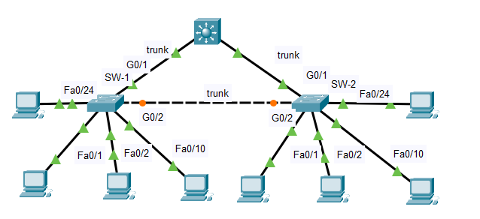

- Configure ports G0/1 and G0/2 as static trunks on both switches.
- Disable DTP negotiation on both sides of the link.
- Create VLAN 100 and give it the name Native on both switches.
- Configure all trunk ports on both switches to use VLAN 100 as the native VLAN.

SW-1 | 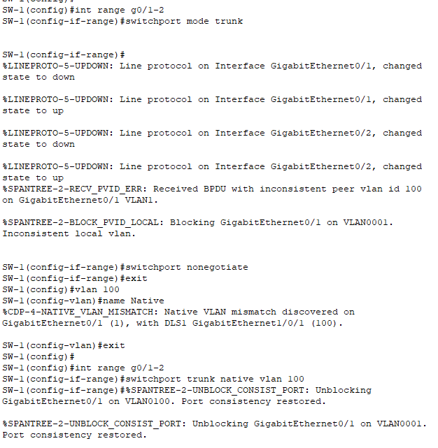  SW-1(config)#int range g0/1-2  SW-1(config-if-range)#switchport mode trunk  SW-1(config-if-range)#switchport nonegotiate  SW-1(config-if-range)#exit  SW-1(config)#vlan 100  SW-1(config-vlan)#name Native  SW-1(config-vlan)#exit  SW-1(config)#int range g0/1-2  SW-1(config-if-range)#switchport trunk native vlan 100
SW-2 | 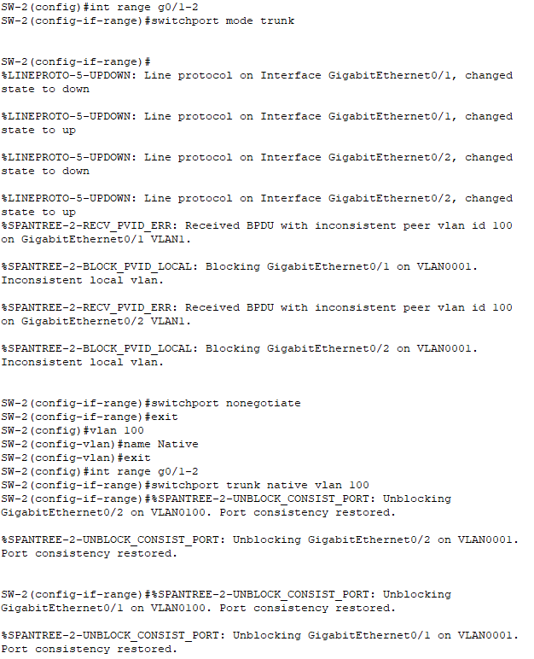  SW-2(config)#int range g0/1-2  SW-2(config-if-range)#switchport mode trunk  SW-2(config-if-range)#switchport nonegotiate  SW-2(config-if-range)#exit  SW-2(config)#vlan 100  SW-2(config-vlan)#name Native  SW-2(config-vlan)#exit  SW-2(config)#int range g0/1-2  SW-2(config-if-range)#switchport trunk native vlan 100

Step 2: Secure Unused Switch Ports.
- Shutdown all unused switch ports on SW-1.
- On SW-1, create a VLAN 999 and name it BlackHole. The configured name must match the requirement exactly.
- Move all unused switch ports to the BlackHole VLAN.
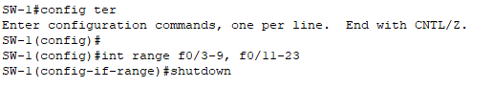
SW-1(config)#int range f0/3-9, f0/11-23
SW-1(config-if-range)#shutdown
SW-1(config-if-range)#exit

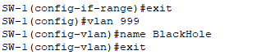
SW-1(config)#vlan 999
SW-1(config-vlan)#name BlackHole
SW-1(config-vlan)#exit

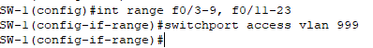
SW-1(config)#int range f0/3-9, f0/11-23
SW-1(config-if-range)#switchport access vlan 999

Step 3: Implement Port Security.
- Activate port security on all the active access ports on switch SW-1.
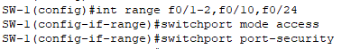
SW-1(config)#int range f0/1-2,f0/10,f0/24
SW-1(config-if-range)#switchport mode access
SW-1(config-if-range)#switchport port-security

- Configure the active ports to allow a maximum of 4 MAC addresses to be learned on the ports.
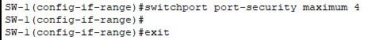
SW-1(config-if-range)#switchport port-security maximum 4

- For ports F0/1 on SW-1, statically configure the MAC address of the PC using port security.
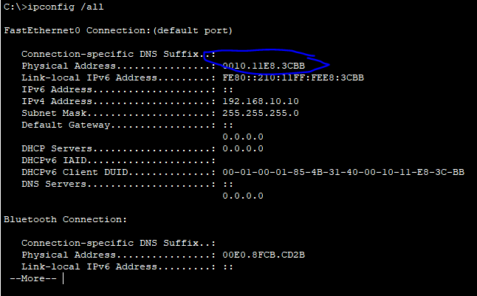
SW-1(config)#int f0/1
SW-1(config-if)#switchport port-security mac-address 0010.11E8.3CBB

- Configure each active access port so that it will automatically add the MAC addresses learned on the port to the running configuration.
SW-1(config)#int range f0/1-2,f0/10,f0/24
SW-1(config-if-range)#switchport port-security mac-address sticky

- Configure the port security violation mode to drop packets from MAC addresses that exceed the maximum, generate a Syslog entry, but not disable the ports.
SW-1(config-if-range)#switchport port-security violation restrict

Step 4: Configure PortFast, and BPDU Guard.
- Enable PortFast on all the access ports that are in use on SW-1.
- Enable BPDU Guard on all the access ports that are in use on SW-1.
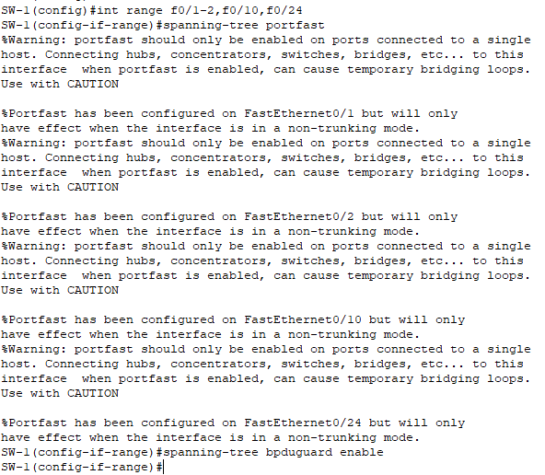

SW-1(config)#int range f0/1-2,f0/10,f0/24
SW-1(config-if-range)#spanning-tree portfast
SW-1(config-if-range)#spanning-tree bpduguard enable

- Configure SW-2 so that all access ports will use PortFast by default.
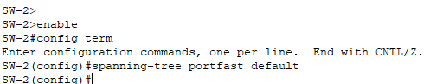
SW-2(config)#spanning-tree portfast default

